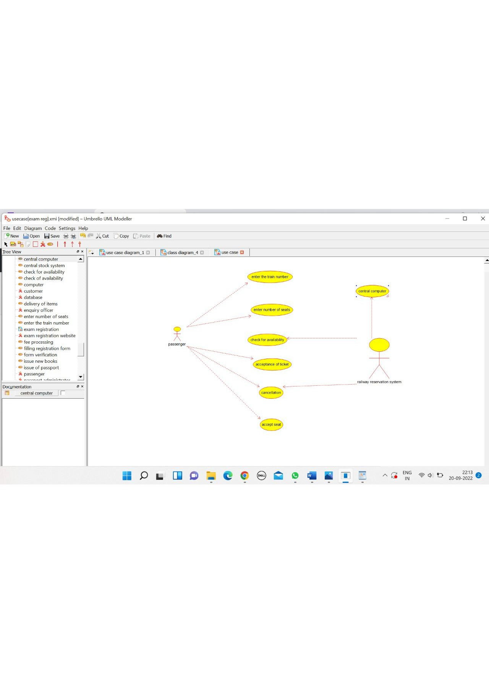

CENTRAL MANAGEMENT

/**

* Class central_management

*/

public class central_management {

//

// Fields

//

private void train_name;

private void passenger_name;

//

// Constructors

//

public central_management () { };

//

// Methods

//

//

// Accessor methods

//

/**

* Set the value of train_name

* @param newVar the new value of train_name

*/

private void setTrain_name (void newVar) {

train_name = newVar;

}

/**

* Get the value of train_name

* @return the value of train_name

*/

private void getTrain_name () {

return train_name;

}

/**

* Set the value of passenger_name

* @param newVar the new value of passenger_name

*/

private void setPassenger_name (void newVar) {

passenger_name = newVar;

}

/**

* Get the value of passenger_name

* @return the value of passenger_name

*/

private void getPassenger_name () {

return passenger_name;

}

//

// Other methods

//

/**

*/

public void reservation()

{

}

/**

*/

public void cancellation()

{

}

/**

*/

public void status()

{

}

/**

*/

public void login()

{

}

/**

*/

public void central_management()

{

}

}

PASSENGER

/**

* Class passenger

*/

public class passenger {

//

// Fields

//

private void name;

private void age;

private void train_number;

//

// Constructors

//

public passenger () { };

//

// Methods

//

//

// Accessor methods

//

/**

* Set the value of name

* @param newVar the new value of name

*/

private void setName (void newVar) {

name = newVar;

}

/**

* Get the value of name

* @return the value of name

*/

private void getName () {

return name;

}

/**

* Set the value of age

* @param newVar the new value of age

*/

private void setAge (void newVar) {

age = newVar;

}

/**

* Get the value of age

* @return the value of age

*/

private void getAge () {

return age;

}

/**

* Set the value of train_number

* @param newVar the new value of train_number

*/

private void setTrain_number (void newVar) {

train_number = newVar;

}

/**

* Get the value of train_number

* @return the value of train_number

*/

private void getTrain_number () {

return train_number;

}

//

// Other methods

//

/**

*/

public void login()

{

}

/**

*/

public void passenger()

{

}

}

RAILWAY RESERVATION SYSTEM

/**

* Class railway_reservation_system

*/

public class railway_reservation_system {

//

// Fields

//

private void train_number;

private void train_name;

private void passenger_name;

//

// Constructors

//

public railway_reservation_system () { };

//

// Methods

//

//

// Accessor methods

//

/**

* Set the value of train_number

* @param newVar the new value of train_number

*/

private void setTrain_number (void newVar) {

train_number = newVar;

}

/**

* Get the value of train_number

* @return the value of train_number

*/

private void getTrain_number () {

return train_number;

}

/**

* Set the value of train_name

* @param newVar the new value of train_name

*/

private void setTrain_name (void newVar) {

train_name = newVar;

}

/**

* Get the value of train_name

* @return the value of train_name

*/

private void getTrain_name () {

return train_name;

}

/**

* Set the value of passenger_name

* @param newVar the new value of passenger_name

*/

private void setPassenger_name (void newVar) {

passenger_name = newVar;

}

/**

* Get the value of passenger_name

* @return the value of passenger_name

*/

private void getPassenger_name () {

return passenger_name;

}

//

// Other methods

//

/**

*/

public void status()

{

}

/**

*/

public void reservation()

{

}

/**

*/

public void cancellation()

{

}

/**

*/

public void railway_reservation_system()

{

}

